- Call to Order: Marsha Williams called the meeting to order at 2:02 PM.
NCLEWA Emergency Meeting to vote on new LOGO – via ZOOM

- Roll Call: Marquie Morrison-Brown

President | Marsha Williams | Present
Vice President | Marquie Morrison-Brown | Present
Treasurer | Jessica West
Secretary | Tayler Alexander | Excused
Sgt. at Arms/Parliamentarian | Maria Stevenson | Present
Chaplain | Marissa Davis | Excused
Historian/Publicity | Debi Smith | Present
Membership Committee Chairperson | Jessica Camera | Present
3 Year Board of Directors | Kim Bell | Excused
 | Tamesha Woolard | Excused
 | Felicia McCabe | Present
2 Year Board of Directors | Wilma Cooley-Griffin
 | Autumn Rose | Present
 | Samantha Lawrence
Justice Academy | Jessica Bullock-Cook | Present
**Additional members in attendance: Lt. Alex Sotelo
Special Agent Laura Kensington
Officer Cashae Baker-Cook
Deputy Kendra Grant
Chief Patrice Andrews

- Questions were asked and answered in reference to new logos. Members voted via poll created by Vice President Marquie Morrison-Brown. Voted started around 0800 hours on 4/3/2023 and ended after the new logo presentation. Vice President Morrison-Brown presented a slide show with all proposed logos. Majority vote was on the logo shown below created by Detective Debi Smith with the Durham, North Carolina Police Department.
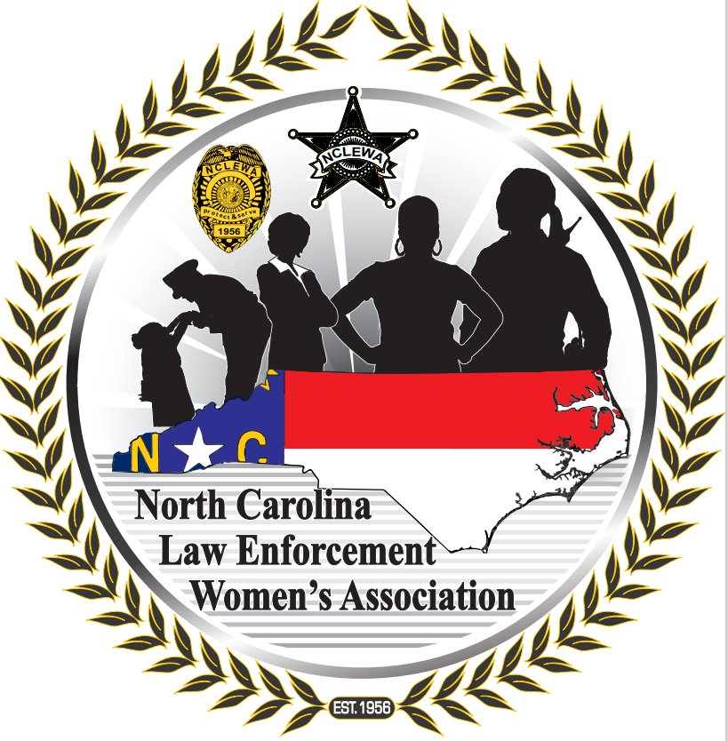

There will be some minor changes that were suggested by members during the live ZOOM meeting. The final product will be presented upon completed. This is a milestone for the North Carolina Law Enforcement Women’s Associated. Thanks to all who participated. Detective Smith and Jessica Cook-Bullock from the North Carolina Justice Academy, and her staff, worked hard for almost two years to help make selecting a new logo possible.

- Meeting adjourned – Motioned by President Marsha Williams and seconded by Vice President Morrison-Brown.

